6.2 Ejercicio de programación 3 y pruebas de unidad

Pruebas de software y aseguramiento de la calidad

Andre M. Hernández Bornn

A01795190

 12 febrero 2025

**Estructura de aplicación**

**Clase Hotel**

**Clase Customer**

**Clase reservation**

**Clase datahandler**

**Código de control**

**Pruebas unitarias clase hotel**

**Pruebas Unitarias Clase Customer**

**Pruebas unitarias clase reservation**

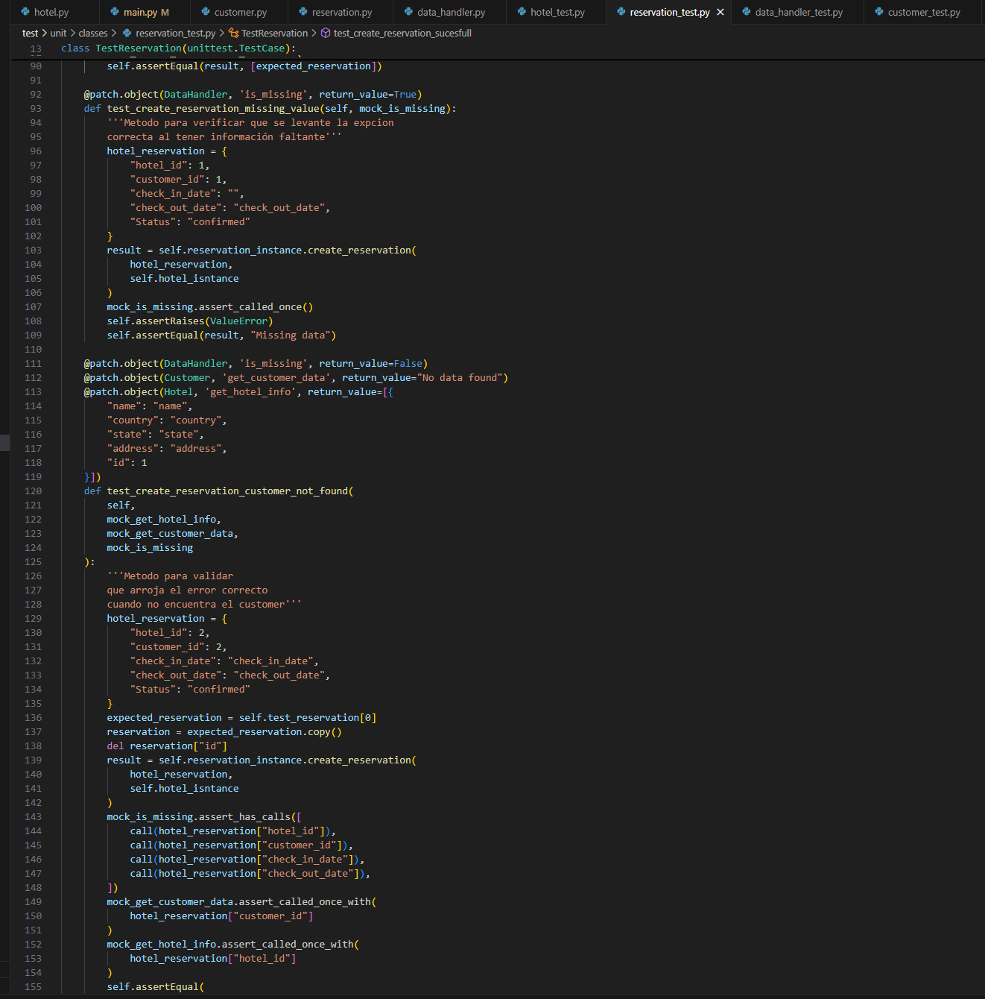

**Pruebas unitarias clase datahandler**

**Resultado flake 8**

**Resultado Pylint**

El error se dejó, ya que ese archivo fue para agregar el correcto formato del modulo y ese debe ser su nombre, no se puede cambiar.

**Pruebas Unitarias Sin errores Clase Hotel**

**Pruebas unitarias Sin errores Clase Customer**

**Pruebas unitarias Sin errores Clase Reservation**

**Pruebas unitarias Sin errores Clase DataHandler**

**Pruebas Unitarias Forzando un error Clase Hotel**

Cambio realizado

Resultado

**Pruebas unitarias Sin errores Clase Customer**

Cambio realizado

Resultado

**Pruebas unitarias Sin errores Clase Reservation**

Cambio realizado

Resultado

**Pruebas unitarias Sin errores Clase DataHandler**

Cambio realizado

Resultado

**Corrida programa de control**

Archivos de datos antes de la corrida

Ejecución programa de control

Archivos de datos después de la corrida

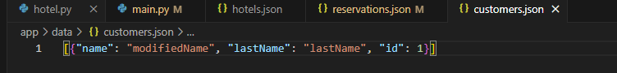

**Code Coverage**

